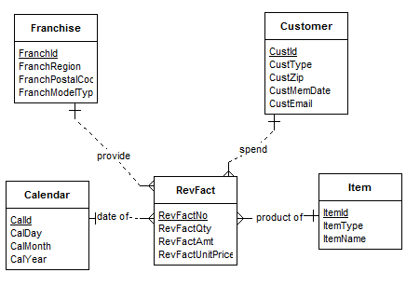

**Summary Generated**

**Entities**

Franchise : REGULAR ENTITY

FranchId : [PK] ATTRIBUTE Type:INTEGER

FranchRegion : ATTRIBUTE Type:VARCHAR Length=20

FranchPostalCode : ATTRIBUTE Type:VARCHAR Length=20

FranchModelType : ATTRIBUTE Type:VARCHAR Length=20

Customer : REGULAR ENTITY

CustId : [PK] ATTRIBUTE Type:INTEGER

CustType : ATTRIBUTE Type:VARCHAR Length=20

CustZip : ATTRIBUTE Type:INTEGER

CustMemDate : ATTRIBUTE Type:DATE

CustEmail : ATTRIBUTE Type:VARCHAR Length=50

Calendar : REGULAR ENTITY

CalId : [PK] ATTRIBUTE Type:INTEGER

CalDay : ATTRIBUTE Type:INTEGER

CalMonth : ATTRIBUTE Type:INTEGER

CalYear : ATTRIBUTE Type:INTEGER

RevFact : REGULAR ENTITY

RevFactNo : [PK] ATTRIBUTE Type:INTEGER

RevFactQty : ATTRIBUTE Type:INTEGER

RevFactAmt : ATTRIBUTE Type:DECIMAL Length=2 Width=10

RevFactUnitPrice : ATTRIBUTE Type:DECIMAL Length=2 Width=10

Item : REGULAR ENTITY

ItemId : [PK] ATTRIBUTE Type:INTEGER

ItemType : ATTRIBUTE Type:VARCHAR Length=20

ItemName : ATTRIBUTE Type:VARCHAR Length=20

**Relationships**

provide : REGULAR RELATIONSHIP Franchise ONE to RevFact MANY

date of : REGULAR RELATIONSHIP Calendar ONE to RevFact MANY

spend : REGULAR RELATIONSHIP Customer ONE to RevFact MANY

product of : REGULAR RELATIONSHIP Item ONE to RevFact MANY